**Ultrasonic Sensor (HC-SR04)**

**Introduction**

The HC-SR04 ultrasonic sensor uses SONAR to determine the distance of an object just like the bats do. It offers excellent non-contact range detection with high accuracy and stable readings in an easy-to-use package from 2 cm to 400 cm or 1” to 13 feet.

The operation is not affected by sunlight or black material, although acoustically, soft materials like cloth can be difficult to detect. It comes complete with ultrasonic transmitter and receiver module.

**Theory**

Ultrasound is a high-pitched sound wave whose frequency exceeds the audible range of human hearing.

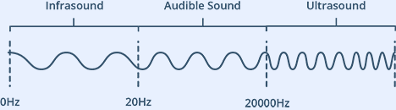

Humans can hear sound waves that vibrate in the range of about 20 times a second (a deep rumbling noise) to 20,000 times a second (a high-pitched whistle). However, ultrasound has a frequency of more than 20,000 Hz and is therefore inaudible to humans.

**Specifications of HC-SR04**

* An HC-SR04 ultrasonic distance sensor actually consists of two [**ultrasonic transducers**](https://en.wikipedia.org/wiki/Ultrasonic_transducer)**.**
* One acts as a transmitter that converts the electrical signal into 40 KHz ultrasonic sound pulses. The other acts as a receiver and listens for the transmitted pulses.
* When the receiver receives these pulses, it produces an output pulse whose width is proportional to the distance of the object in front.
* This sensor provides excellent non-contact range detection between 2 cm to 400 cm (~13 feet) with an accuracy of 3 mm.
* Since it operates on 5 volts, it can be connected directly to an Arduino or any other 5V logic microcontroller.

**Pinout of HC-SR04 (Ultrasonic Sensor)**

Technical Specifications:

|  |  |
| --- | --- |
| **Operating Voltage** | DC 5V |
| **Operating Current** | 15mA |
| **Operating Frequency** | 40KHz |
| **Max Range** | 4m |
| **Min Range** | 2cm |
| **Ranging Accuracy** | 3mm |
| **Measuring Angle** | 15 degree |
| **Trigger Input Signal** | 10µS TTL pulse |
| **Dimension** | 45 x 20 x 15mm |

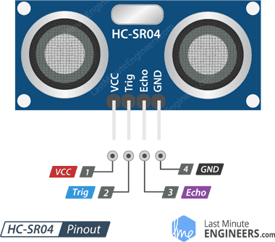

VCC supplies power to the HC-SR04 ultrasonic sensor. You can connect it to the 5V output from your Arduino.

Trig (Trigger) pin is used to trigger ultrasonic sound pulses. By setting this pin to HIGH for 10µs, the sensor initiates an ultrasonic burst.

Echo pin goes high when the ultrasonic burst is transmitted and remains high until the sensor receives an echo, after which it goes low. By measuring the time, the Echo pin stays high, the distance can be calculated.

GND is the ground pin. Connect it to the ground of the Arduino.

**Working of HC-SR04 (Ultrasonic Sensor)**

It all starts when the trigger pin is set HIGH for 10µs. In response, the sensor transmits an ultrasonic burst of eight pulses at 40 kHz. This 8-pulse pattern is specially designed so that the receiver can distinguish the transmitted pulses from ambient ultrasonic noise.

These eight ultrasonic pulses travel through the air away from the transmitter. Meanwhile the echo pin goes HIGH to initiate the echo-back signal.

If those pulses are not reflected back, the echo signal times out and goes low after 38ms (38 milliseconds). Thus, a pulse of 38ms indicates no obstruction within the range of the sensor.

If those pulses are reflected back, the echo pin goes low as soon as the signal is received. This generates a pulse on the echo pin whose width varies from 150 µs to 25 ms depending on the time taken to receive the signal.



**Calculating the Distance**

Speed of the sound = 340 m/s at **20 $°$ C**

Speed of the sound (in cm/µs) = 0.034 cm/µs

**Distance = (0.034 cm/µs) x [Time Taken (in µs)]/ 2**

Distance = Speed x Time

**Expected Output**

